**TEJAS MONPARA**

**GITHUB VCS EXERCISES**

EXERCISE-1 Create your first Commit.

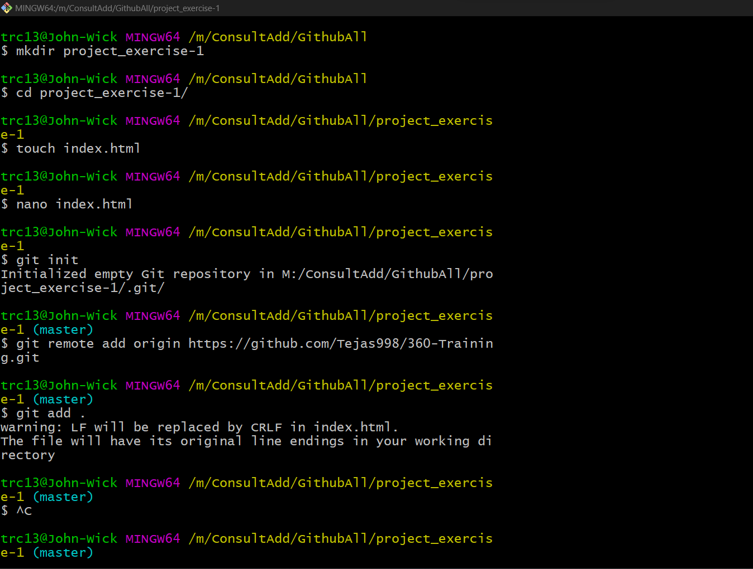

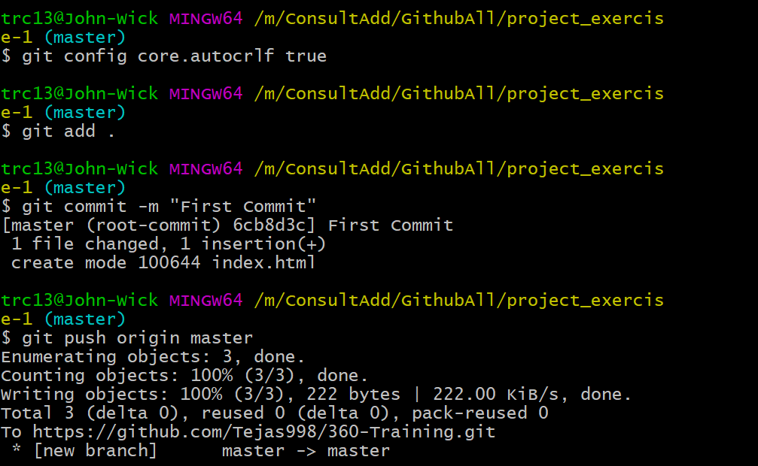

Exercise 2: Commit only one file.

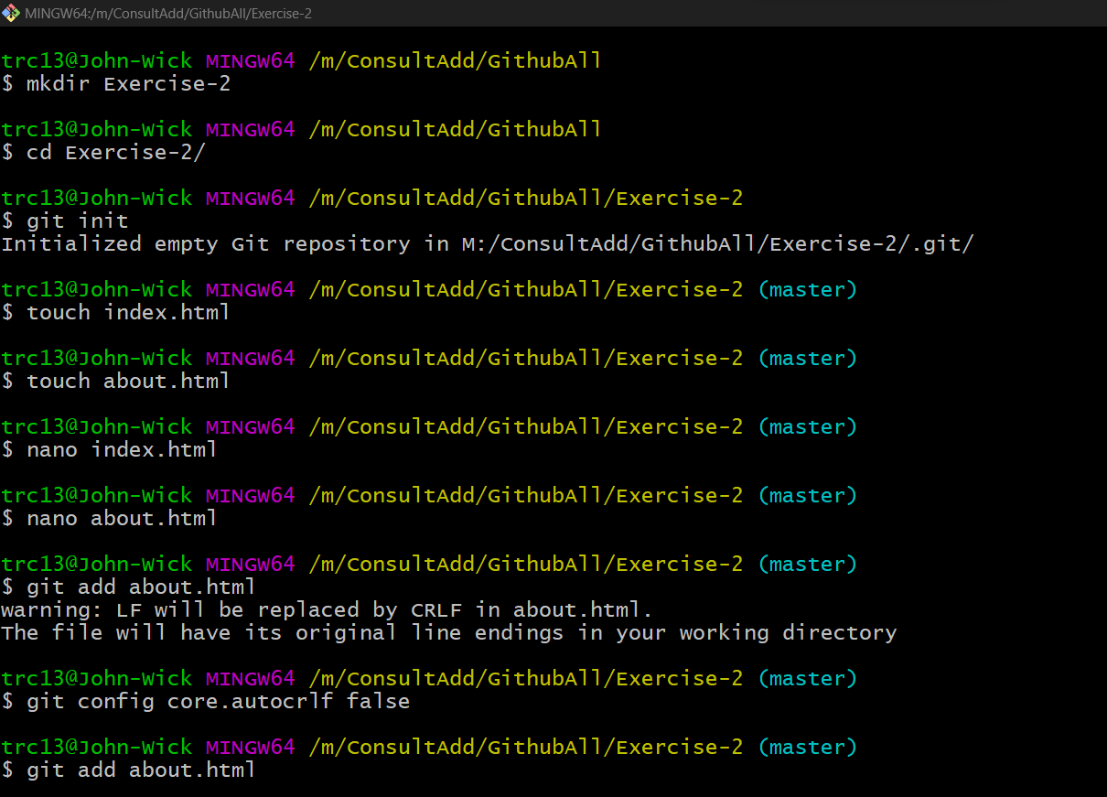

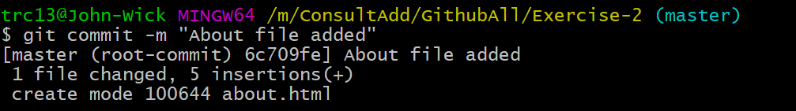

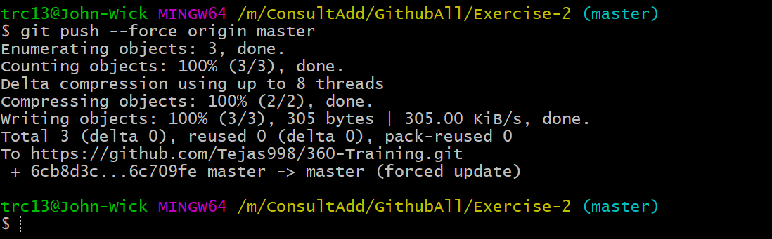

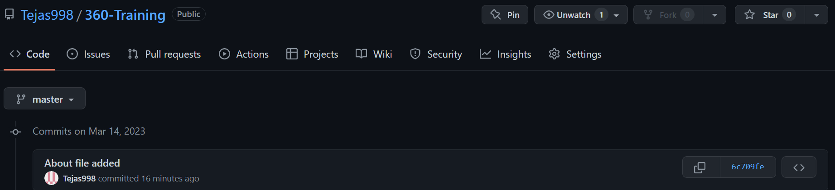

Exercise 3: Modify last commit.

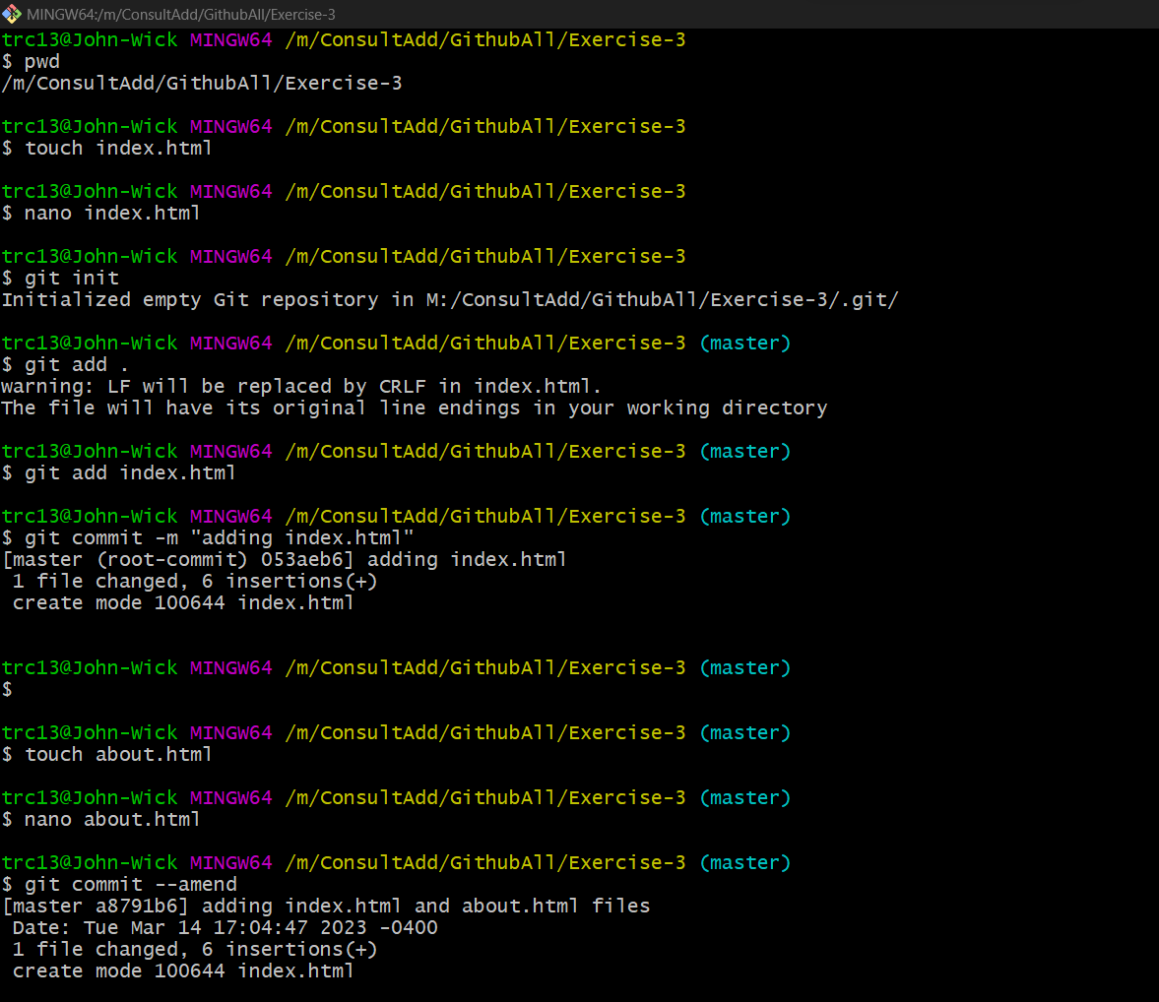

Exercise 4: Create git ignore file



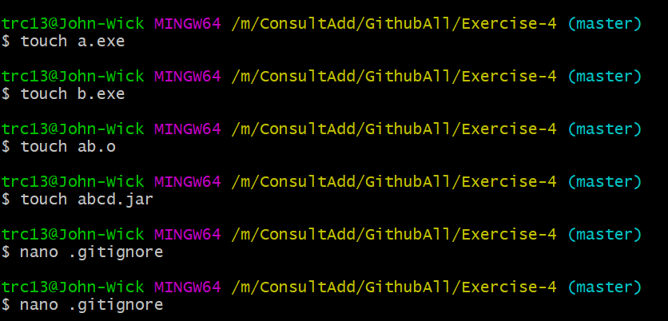

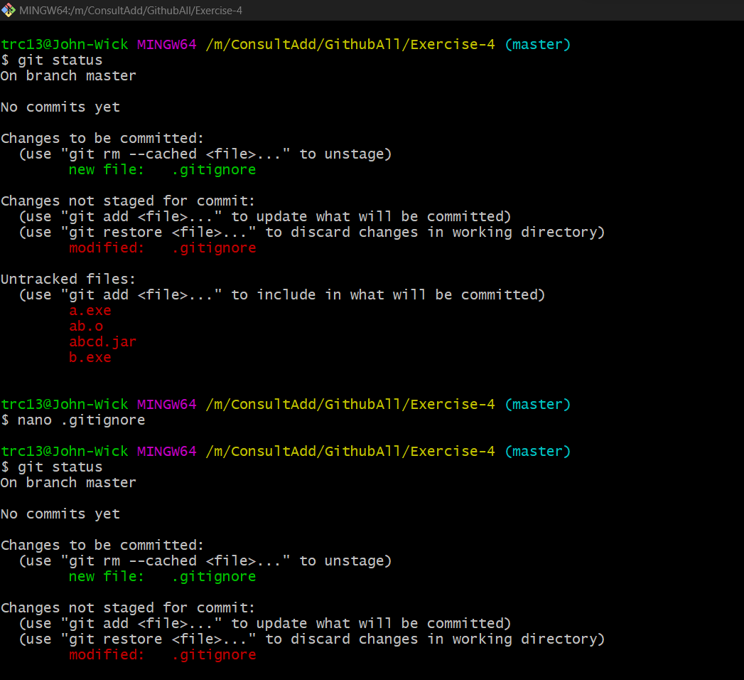

Exercise 5: Save your work with stash.

Did changes in file.html and added stash (Added Head tag)

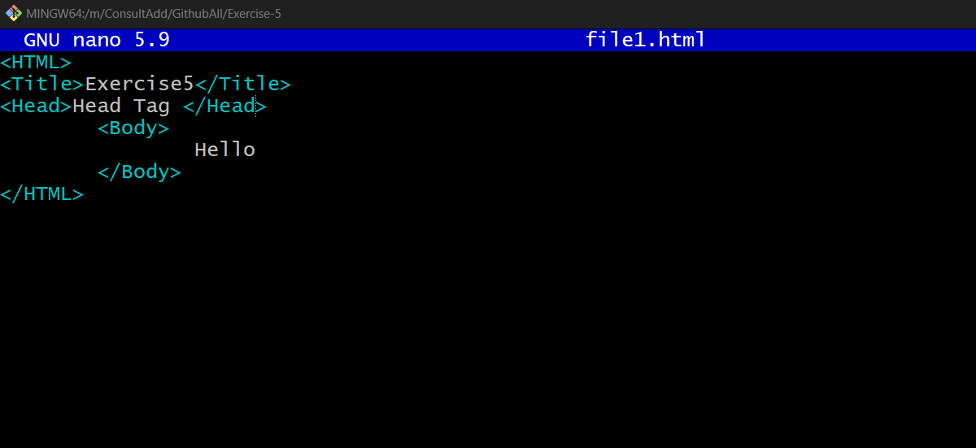

After adding stash

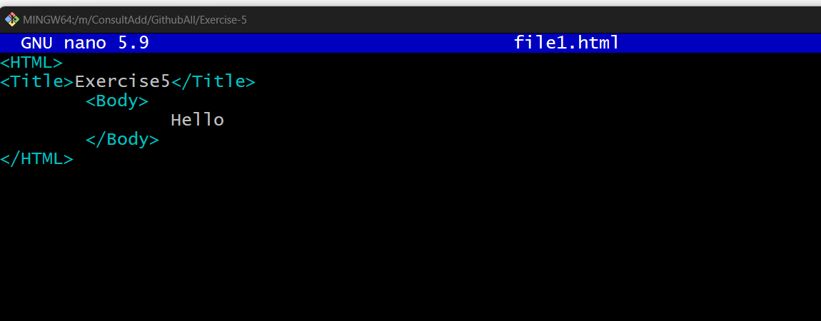

Getting back that head tag with stash apply

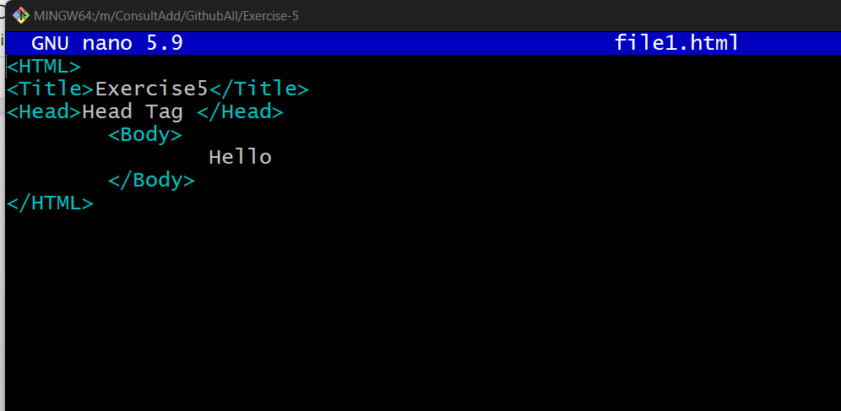

All commands:

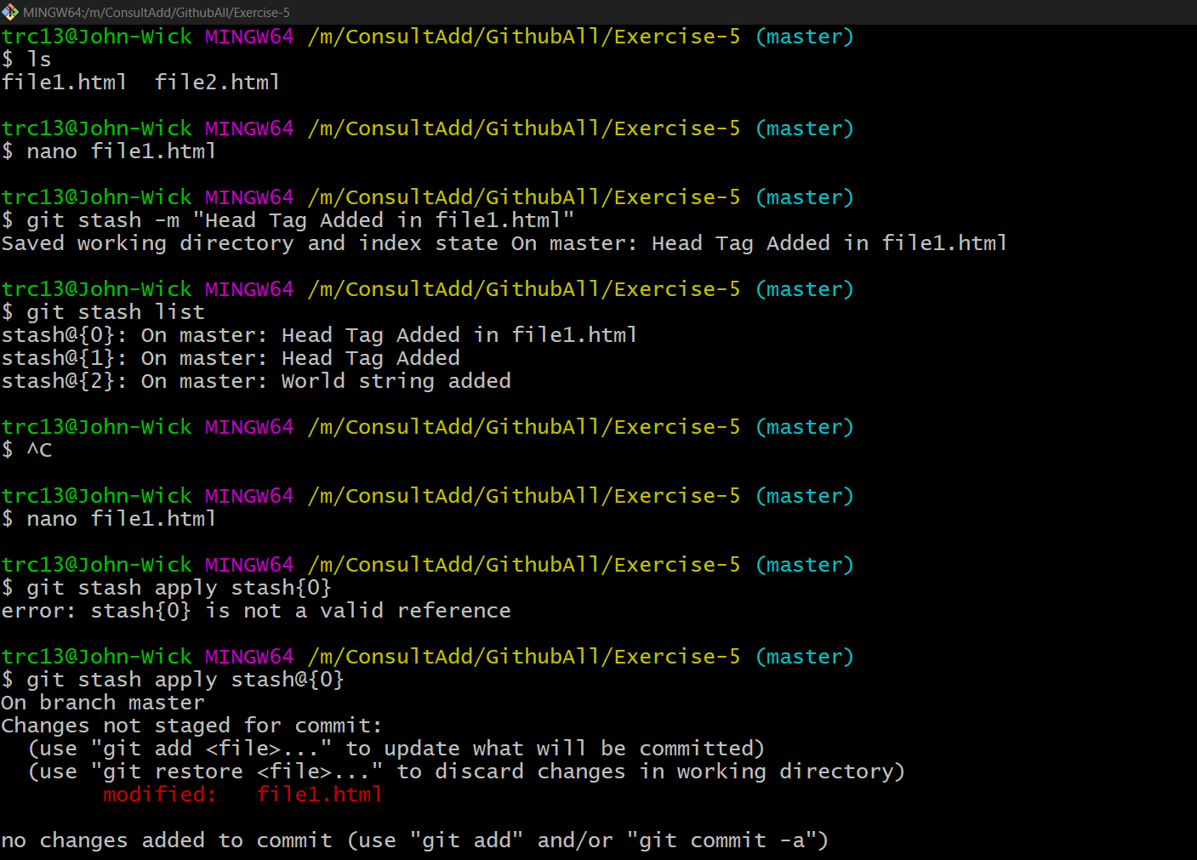

Exercise 6: Reset Previous Commit Keeping changes. (Soft Reset)

Soft reset

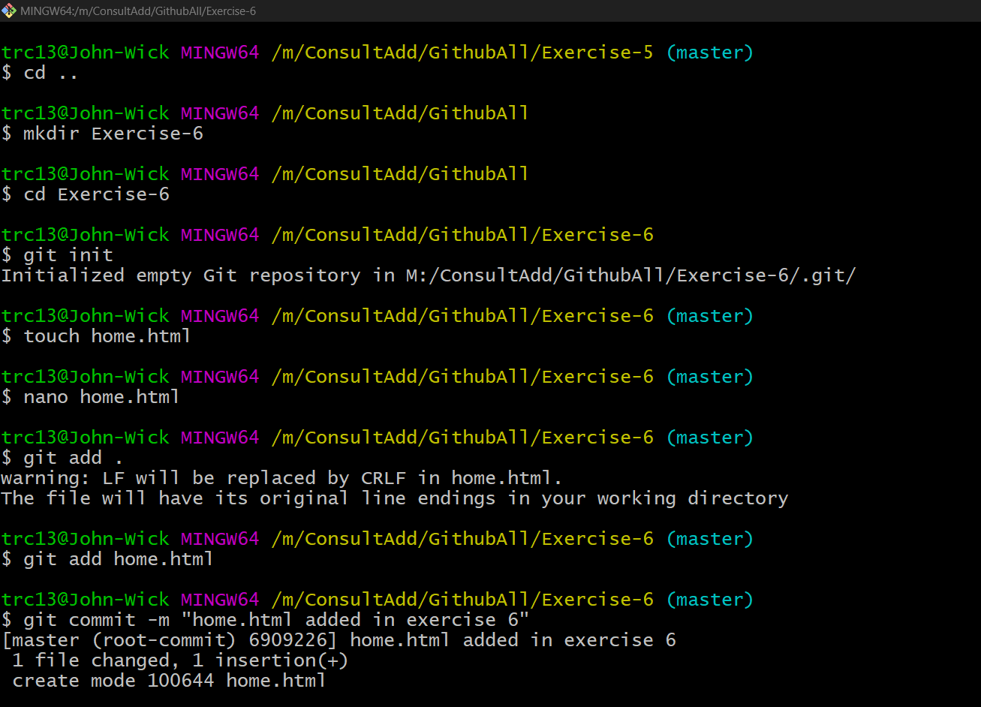

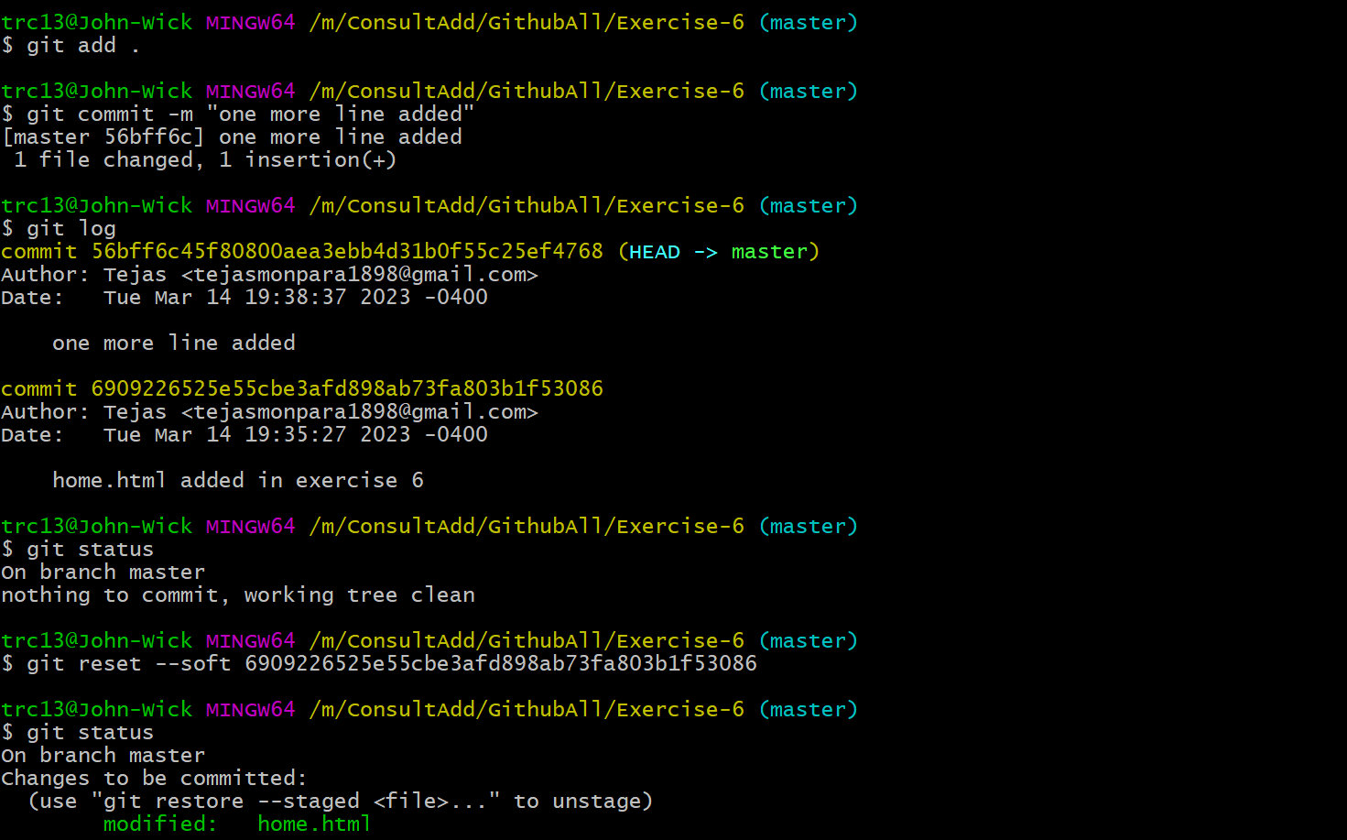

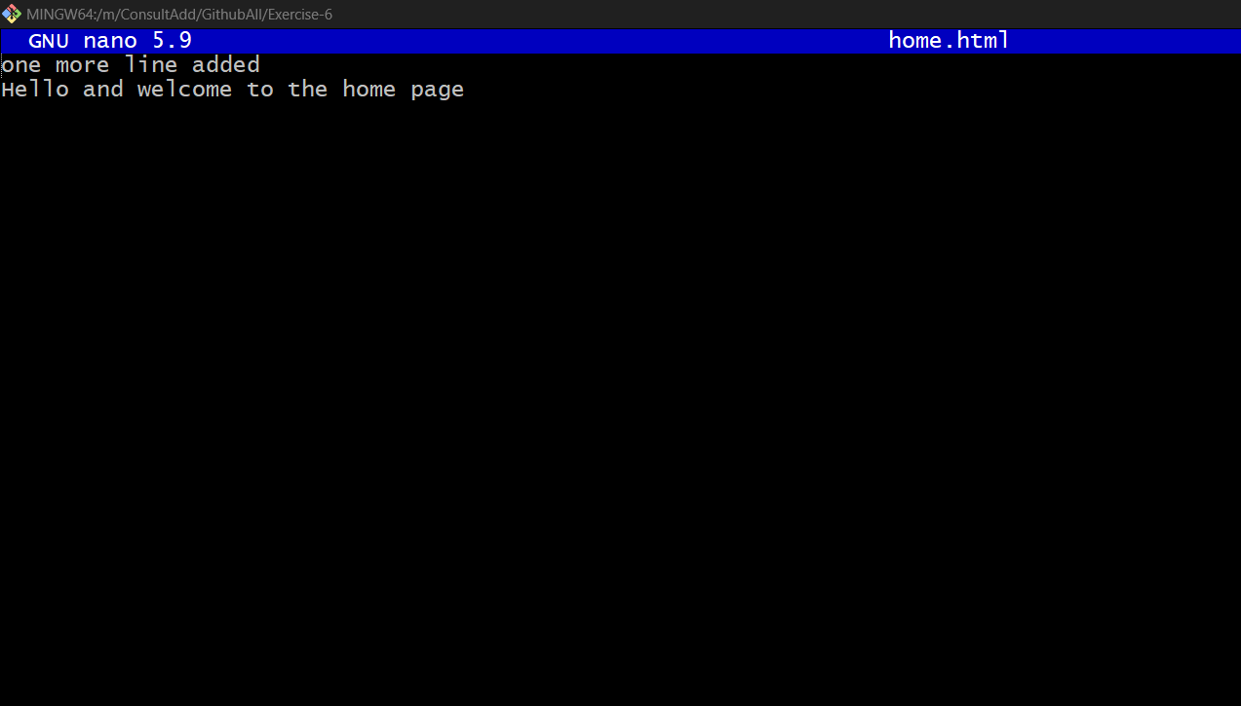

Exercise 7: Reset Previous Commit (Hard Reset).

File Home.html

Total 3 commit added

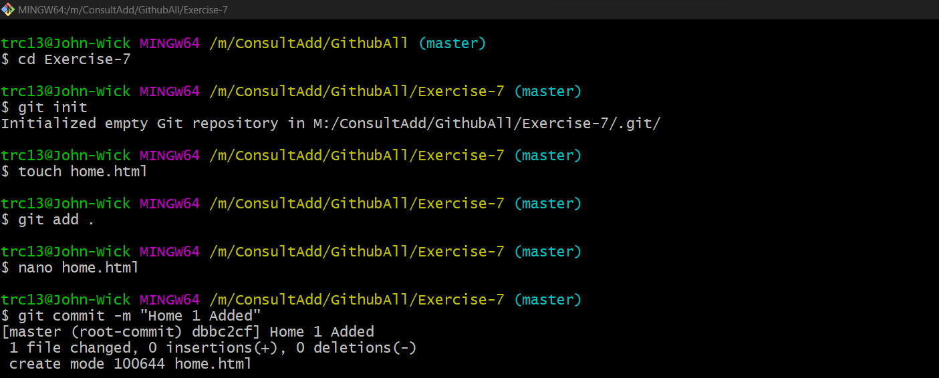

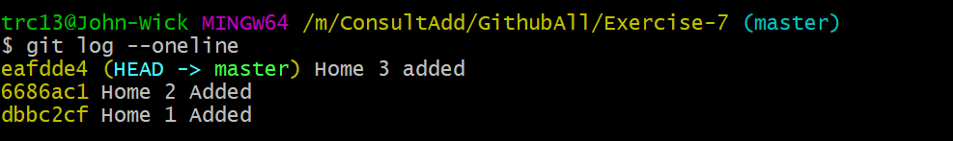

Now Hard reset till Home 2

Final output:

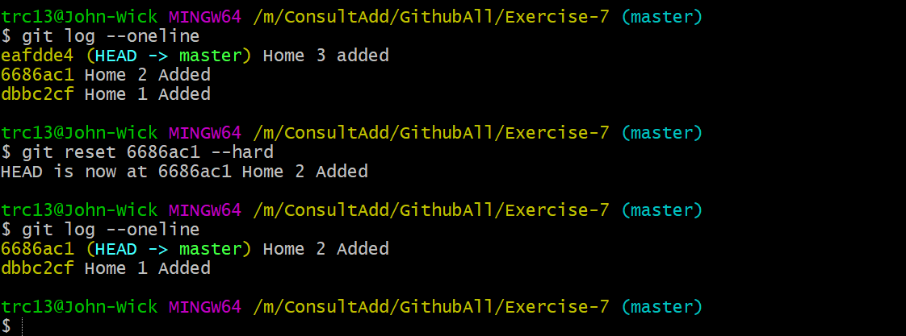

Exercise 8: Merge branch (No Conflicts).

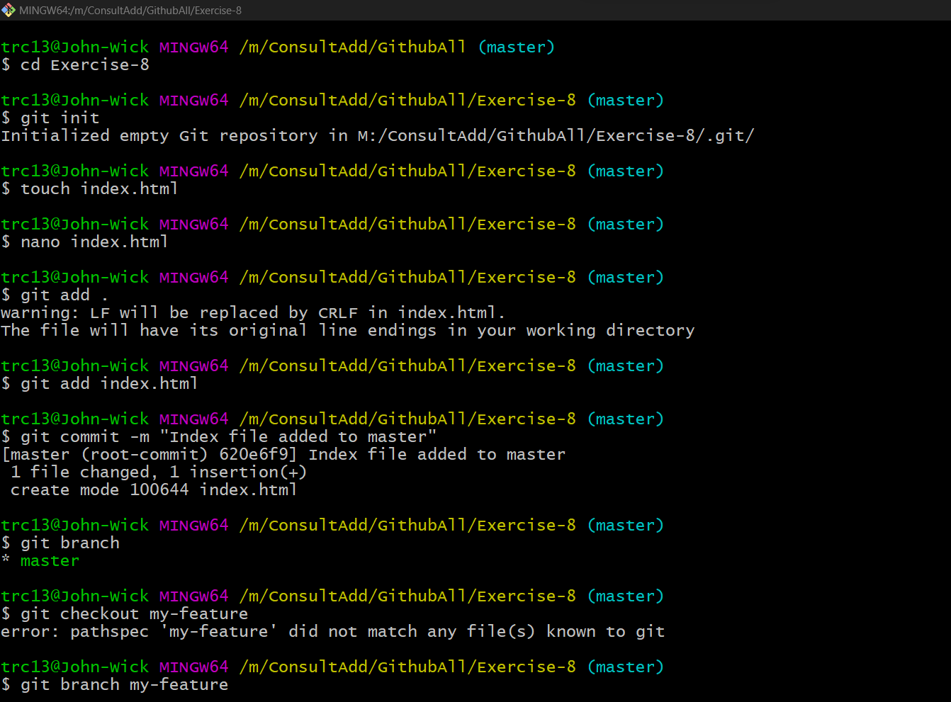

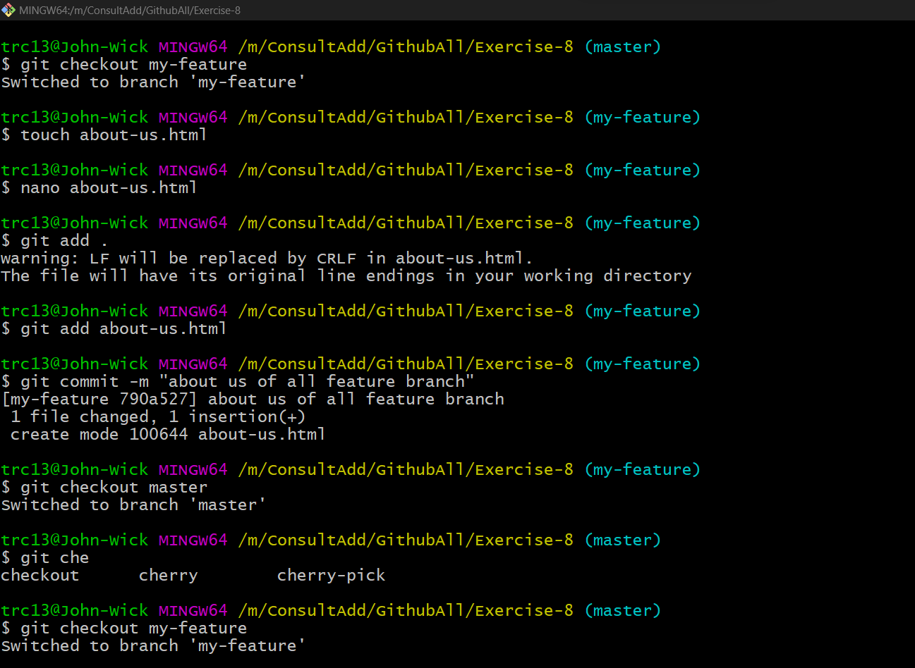

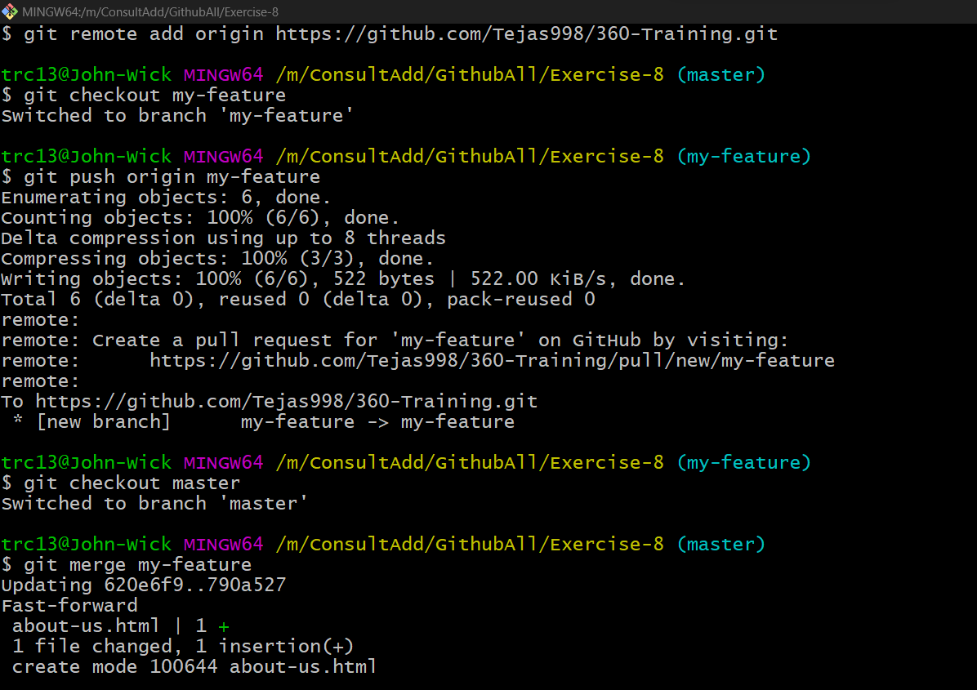

Then git push origin master to push the changes

